

**DR. D. Y. PATIL SCHOOL OF SCIENCE AND TECHNOLOGY**

**TATHAWADE, PUNE**

**A Mini- Project Report on**

**Smart Recipe Recommender**

**SUBMITTED BY:**

**NAME OF STUDENT ROLL NUMBER**

**1. Ishita Saxena BTAI-47**

**2 Ishwari Warhade BTAI-59**

**3. Himanshu Chaudhari BTAI-9**

**GUIDED BY:**

**Mrs . MILY LAL**

**ARTIFICIAL INTELLIGENCE & DATA SCIENCE**

**ACADEMIC YEAR 2023-2027**



**DR. D. Y. PATIL SCHOOL OF SCIENCE AND TECHNOLOGY**

**TATHAWADE, PUNE**

**CERTIFICATE**

**This is to certify that the Mini- Project Report entitled**

**-“ Smart Recipe Recommender “-**

is a bonafide work carried out by Ms. Suridhi Gupta under the supervision of **Mrs. Mily Lal** and it is submitted towards the partial fulfillment of the requirement Project Based Learning-I.

Mrs. Mily Lal Prof. Manisha Bhende

**Project Guide HOD (DPSST)**

**ARTIFICIAL INTELLIGENCE & DATA SCIENCE**

**ACADEMIC YEAR 2023-2027**

**ABSTRACT**

In today’s fast-paced and convenience-driven world, people frequently struggle with the question, “What should I cook today?” This everyday dilemma is especially common among students, working professionals, and homemakers who have limited time and often end up wasting ingredients they already have at home. The lack of inspiration or knowledge about what can be prepared with available ingredients leads to increased dependence on takeout or pre-packaged food, which not only affects physical health but also contributes to significant food wastage and increased household expenses.This project proposes the development of a smart, AI-powered recipe recommendation system designed to address this challenge. By utilizing Natural Language Processing (NLP) and Machine Learning (ML), the system will analyze user-input ingredients and generate suitable recipes accordingly. In addition to ingredient-based suggestions, users can apply multiple filters based on dietary restrictions (such as vegan, gluten-free, keto), cuisine preferences (e.g., Indian, Chinese, Italian, Mediterranean), and even cooking difficulty levels (easy, moderate, advanced). This provides a highly personalized experience, ensuring that the suggestions meet individual health goals, taste preferences, and available cooking time.To build this system, the project will use datasets sourced from reputable platforms such as Kaggle, along with APIs like Spoonacular and Edamam, which offer access to a large variety of recipe metadata including ingredient lists, nutrition facts, and tags. The ultimate goal is to make everyday cooking a smarter, healthier, and more sustainable activity while minimizing decision fatigue and food waste. This tool not only empowers users with creative meal ideas but also fosters better eating habits, improved ingredient utilization, and greater awareness about food.

**Keyword:** Recipe Recommendation, Machine Learning, Natural Language Processing, Food Waste Reduction, Personalized Cooking, Smart Kitchen Assistant

\

**INDEX**

|  |  |  |
| --- | --- | --- |
| **SR.NO** | **TOPIC** | **PAGE NO** |
| 1] | INTRODUCTION |  |
| 1.1 Problem Statements |  |
| 1.2 Objective |  |
| 1.3 Scope |  |
| 1.4 System Architecture |  |
| 2] | DATA COLLECTION & PREPROCESSING |  |
| 2.1 Dataset |  |
| 2.2 Data Preprocessing |  |
| 3] | MODEL SELECTION & TRAINING |  |
| 3.1 Feature Engineering |  |
| 3.2 Machine Learning Model |  |
| 4] | MODEL EVALUATION AND VALIDATION |  |
| 4.1 Performance Metrics |  |
| 5] | CONCLUSION & FUTURE SCOPE |  |
| 6] | REFERENCES |  |

**List of Figures**

|  |  |  |
| --- | --- | --- |
| **SR.NO** | **FIGURE NO.** | **PAGE NO** |
| **1** | System Architecture |  |
|  |  |  |
|  |  |  |

**Chapter 1**

**INTRODUCTION**

In today’s fast-paced lifestyle, deciding what to cook can be a daily struggle—especially when you only have limited ingredients at home. This often leads to food wastage or unhealthy eating choices like ordering takeout. To solve this common problem, we present a smart recipe recommendation system that suggests recipes based on ingredients the user already has.

This system leverages Natural Language Processing (NLP) and Machine Learning (ML) techniques. By using TF-IDF vectorization and the K-Nearest Neighbors (KNN) algorithm, it identifies the most relevant recipes from a large dataset. Users simply input the ingredients they have, and the system returns a list of recipes that best match their input.

The goal is to promote sustainable cooking, minimize waste, and make home cooking easier and healthier—all using the power of data science.

**1.1. Problem Statement**

Many individuals struggle to decide what to cook based on the ingredients they currently have, often leading to unnecessary food wastage and unhealthy dietary habits. This issue becomes more prominent for busy professionals, students, or people with specific dietary restrictions. Addressing this problem is crucial for promoting sustainable living, reducing daily decision fatigue, and encouraging nutritious eating. A recipe recommendation system can be a valuable solution by offering smart, personalized suggestions based on available ingredients. Stakeholders include home cooks, health-conscious individuals, students, and families who seek quick, cost-effective, and healthy meal ideas

**1.2.Objective**

* . To develop a recipe recommendation system that suggests dishes based on user-input ingredients.
* To integrate filters for dietary preferences, cuisine types, and cooking difficulty for personalized suggestions.
* To implement NLP and ML techniques to enhance the accuracy and relevance of recipe recommendations**.**

**1.3. Scope**

**Limitations**

* **Ingredient Match Only:** The system relies solely on ingredient matching and doesn’t consider quantities or cooking techniques, which may lead to slightly irrelevant results.
* **No Cooking Time or Dietary Filter Yet**: Currently, the system doesn’t account for cooking time, difficulty level, or dietary restrictions (like vegan or gluten-free), limiting personalization.
* **Ingredient Input Format:** The accuracy of recommendations depends on how users enter ingredients. Misspellings or uncommon ingredient names might affect the results.

**Intended Audience**

* **Home Cooks & Beginners**: Individuals who cook regularly at home or are new to cooking and need quick recipe suggestions based on what they already have.
* **Students & Working Professionals**: People with limited time, ingredients, or cooking skills—like college students or busy employees—looking for simple, no-fuss meal ideas.
* **Health-Conscious Users:** Users trying to avoid takeout and make healthier choices using home-cooked meals tailored to available ingredients.
* **Sustainable Living Enthusiasts**: Individuals who want to reduce food waste by using up the ingredients they already have instead of letting them spoil

**1.4 System Architecture**

**Chapter 2**

**DATA COLLECTION & PREPROCESSING**

**2.1. Dataset**

The dataset used for this project is a parsed and pre-processed collection of recipe ingredients extracted from a broader recipe dataset. It includes textual entries that list ingredients along with their quantities, units, and preparation instructions.

Dataset Features:

| Column Name | Description |
| --- | --- |
| Ingredients | Original unstructured ingredient text |
| Amount | Extracted numerical quantity (e.g., 1, 2.5, ½) |
| Unit | Measurement unit (e.g., cup, tbsp, g, ml) |
| Ingredient Name | Cleaned and standardized ingredient name |
| Preparation Instructions | Any additional preparation steps (e.g., "chopped", "boiled") |

This dataset is highly relevant as the project focuses on clustering similar ingredients to help in:

* Recipe standardization
* Ingredient substitution suggestions
* Building smarter grocery lists based on grouped items
* Future recommendation systems for cooking and meal prep

The cleaned and structured version of the dataset allowed us to apply feature engineering (like converting amounts to numerical values) and then perform clustering using ML models like DBSCAN, KMeans, and Agglomerative Clustering.

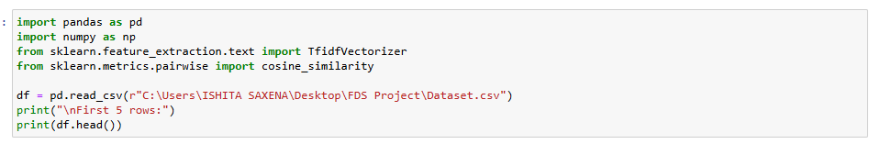

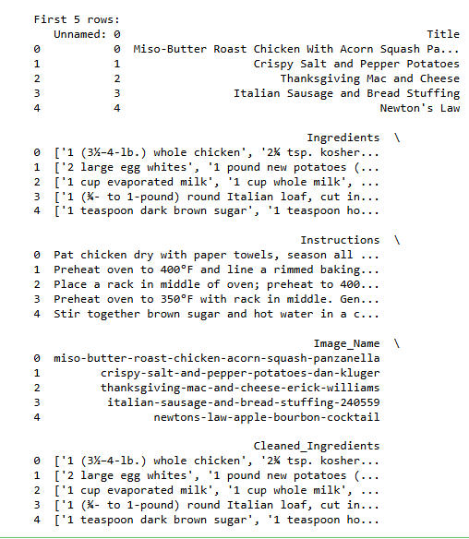

Fig.2.1

**2.2. Data Preprocessing**

To prepare the dataset for machine learning and clustering, several preprocessing steps were carried out. The raw ingredient data was unstructured, so we applied cleaning and extraction techniques to make it suitable for modeling.

1. **Handling Missing Values**  
   The dataset contained some missing values, particularly in text-based columns. These were handled by replacing missing entries with empty strings to ensure uniformity and avoid interruptions during parsing and clustering processes.

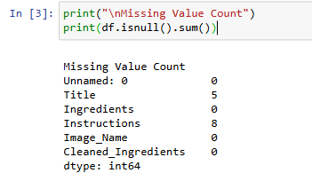

Fig.2.2

1. **Removing Duplicates**  
   Duplicate entries were identified and removed to maintain data quality and avoid skewing the results of clustering models. This ensured that each ingredient entry was unique and relevant.

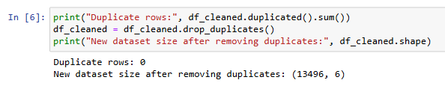

Fig.2.3

1. **Correcting Inconsistent Formats**  
   Many ingredient entries were unstructured or inconsistent in format. These were standardized using regular expressions to extract the ingredient name, amount, and unit. Additionally, textual or fractional quantities were converted to numeric values to enable accurate numerical analysis.

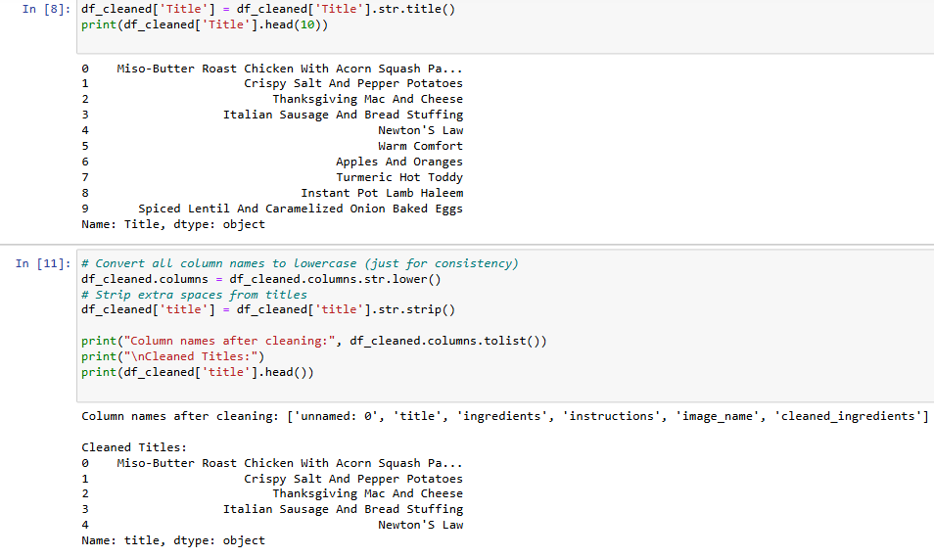

Fig.2.4

1. **Handling Outliers**  
   Outliers in the numeric "Amount" column were identified using the Interquartile Range (IQR) method. Extreme values beyond the acceptable range were removed to prevent them from distorting the clustering models.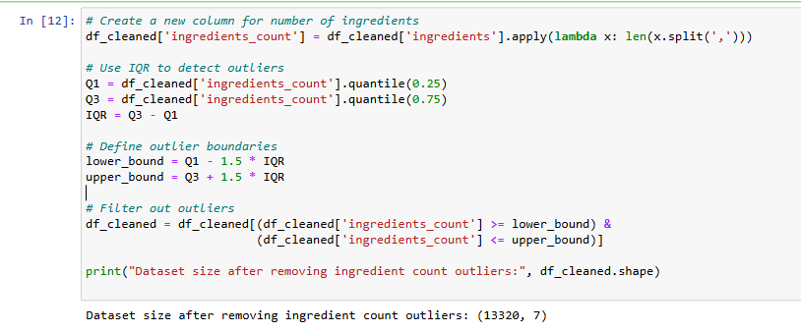

Fig.2.5

1. **Exploratory Data Analysis (EDA)**  
   Descriptive statistics such as mean, median, mode, standard deviation, and variance were computed to understand the distribution of ingredient amounts. This helped in identifying patterns and central tendencies within the dataset

.

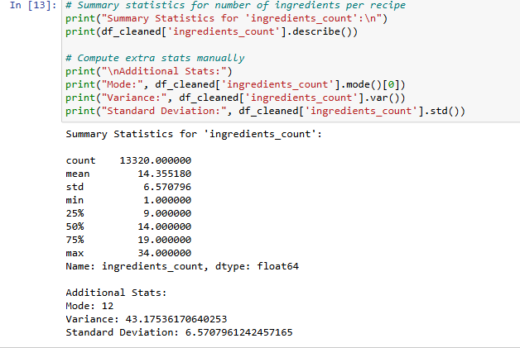

Fig.2.6

**Chapter 3**

**MODEL SELECTION & TRAINING**

**3.1. Feature Engineering**

Feature engineering involves transforming raw data into meaningful features that improve the performance of machine learning models.

* New Features Created:
  + ingredients_count: Calculated by counting the number of ingredients listed in the ingredients column. This provides insight into the complexity of each recipe.
  + steps_count: Estimated by splitting the instructions text by periods to count the number of steps in a recipe. This helps measure the procedural length of each recipe

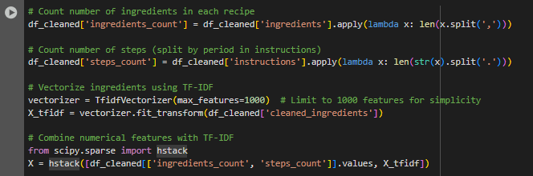

Fig.3.1

* Data Transformation:
  + Cleaned and standardized categorical values (e.g., title casing of recipe names, trimming extra spaces).
  + Ensured consistent column naming for uniformity.

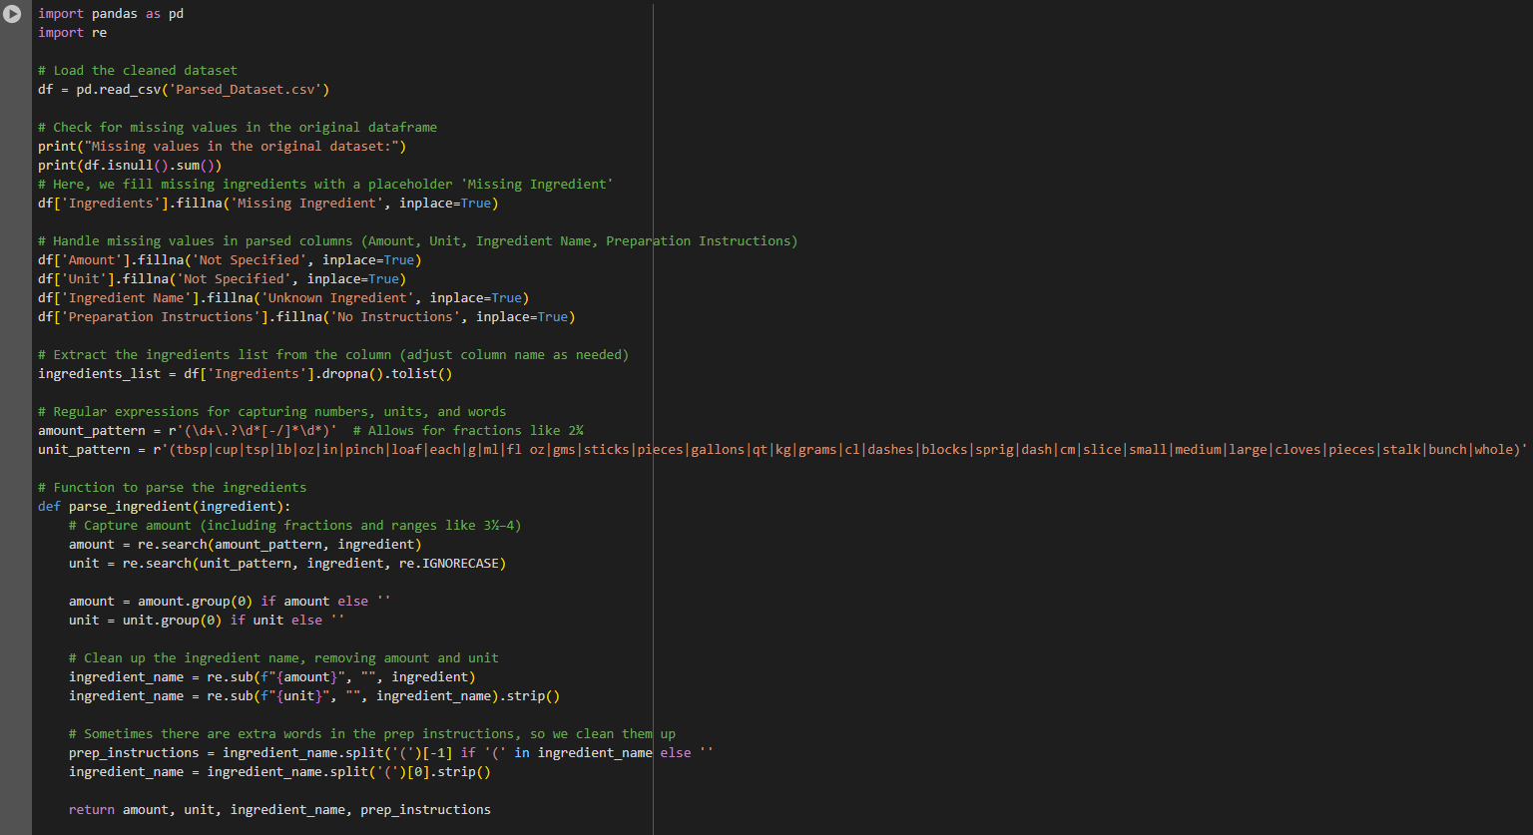

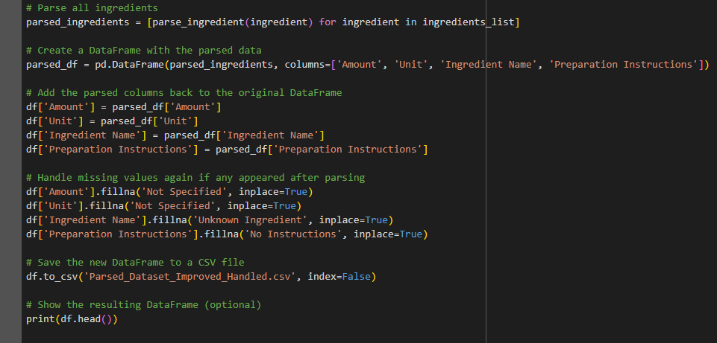

Fig.3.2

* Dimensionality Reduction:
  + Applied PCA (Principal Component Analysis) to reduce multivariate data to two principal components for visualization and clustering. PCA helps in visualizing high-dimensional data in 2D without losing much variance.

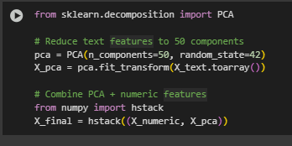

Fig.3.3

* Visualizations Used:
  + Histogram to show the distribution of ingredients_count.

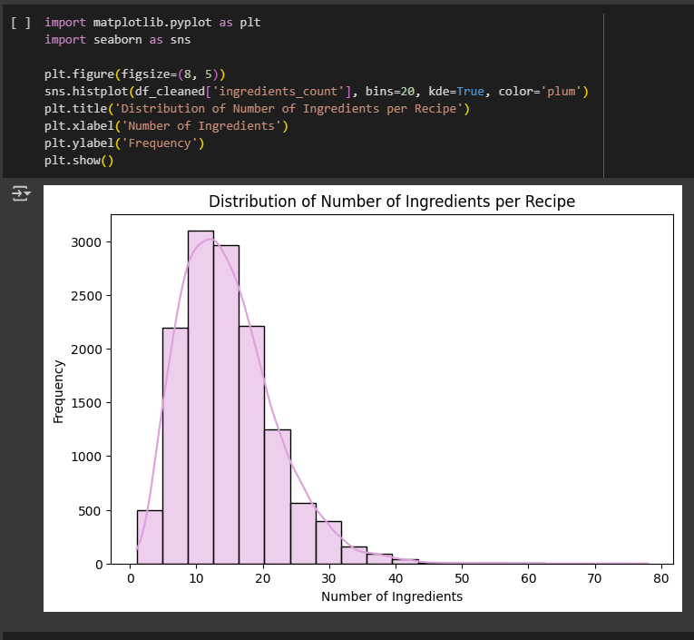

Fig.3.4

* + Boxplot to detect outliers in the number of ingredients.

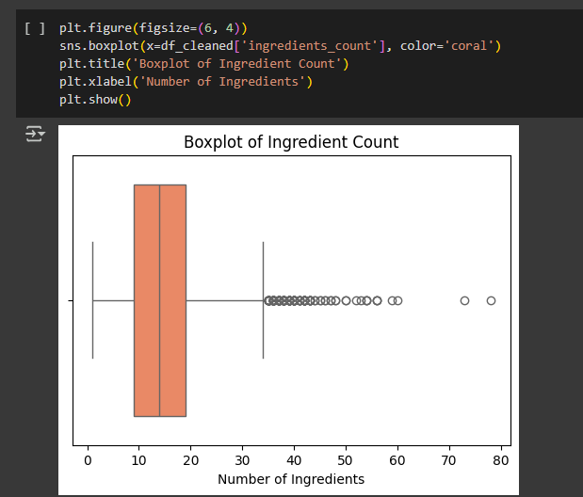

Fig.3.5

* + Scatter Plot to explore the relationship between ingredients_count and steps_count.

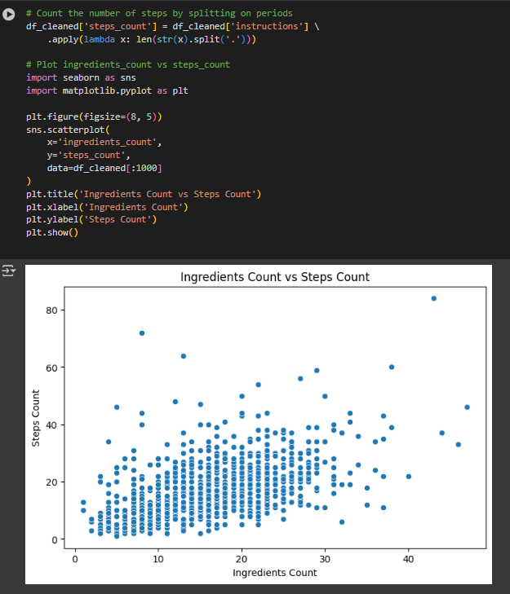

Fig.3.6

**3.2. Machine Learning Model**

**i. Choosing Appropriate Machine Learning Models**

Given that the dataset contains structured recipe information (ingredient lists, preparation instructions, etc.) with limited numeric features, the problem is best suited for clustering. Clustering is an unsupervised learning technique that helps group similar recipes based on their characteristics, which can include ingredients and preparation methods.

Clustering: This approach is ideal for grouping recipes that share similar features. Since there are not many numeric features available, we can use techniques like TF-IDF vectorization (which converts ingredients into a numeric format) to capture similarities between recipes based on ingredient composition.

* K-Means Clustering: K-Means is an efficient clustering algorithm that groups data into clusters based on similarity. Given the ingredient data, K-Means can group recipes based on similar ingredient patterns and help identify hidden structures in the dataset
* DBSCAN (Density-Based Spatial Clustering of Applications with Noise): An alternative to K-Means, DBSCAN can be useful when the data contains noise or outliers, as it can form clusters of varying shapes and sizes.
* Agglomerative Clustering: This hierarchical clustering method builds clusters iteratively by merging the closest pairs of points. It works well when you want to explore how data clusters at different levels of similarity.

**i. Train Multiple Clustering Models to Compare Performance**.

**Clustering Models Used:**

1. **K-Means Clustering**:
   * **K-Means** is a centroid-based clustering algorithm where the data is divided into **K** clusters based on similarity. The number of clusters, **K**, is specified by the user.
   * The model assigns recipes to clusters based on the similarity of their ingredients and preparation instructions, and tries to minimize the distance between recipes within the same cluster.
   * **Comparison Metric**: Inertia (sum of squared distances between points and their assigned cluster center). A lower inertia indicates better clustering.

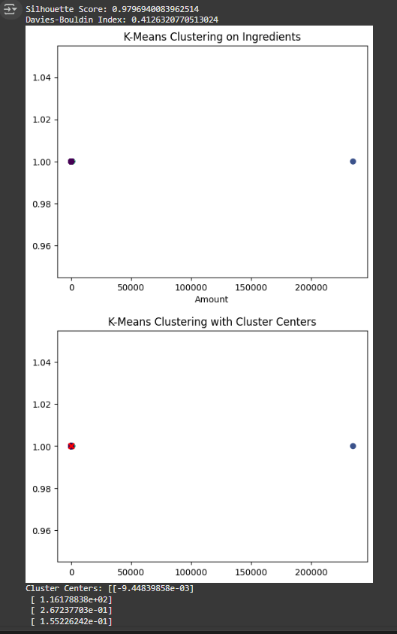

Fig.3.7

1. **DBSCAN (Density-Based Spatial Clustering of Applications with Noise)**:
   * **DBSCAN** is a density-based clustering algorithm that can find clusters of varying shapes and sizes. It does not require the user to specify the number of clusters, and it can handle noise (outliers) effectively.
   * DBSCAN groups together points that are closely packed while marking outliers as noise. This can be useful for recipes that may not fit into the predefined clusters.
   * **Comparison Metric**: Silhouette Score (measuring how similar an object is to its own cluster compared to other clusters). Higher scores indicate better-defined clusters.

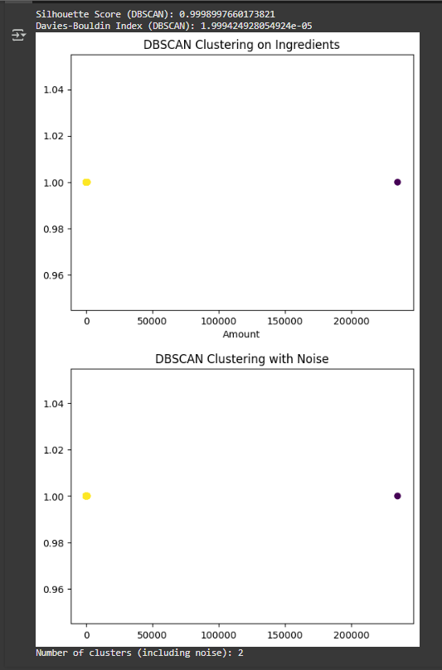

Fig.3.8

1. **Agglomerative Clustering**:
   * **Agglomerative Clustering** is a hierarchical clustering method that builds a tree of clusters. Unlike K-Means, it does not require specifying the number of clusters beforehand.
   * This model iteratively merges the closest clusters and can offer different views of the data at different levels of granularity.
   * **Comparison Metric**: Dendrogram visualization and Silhouette Score to assess how well the data has been grouped at different hierarchical levels.

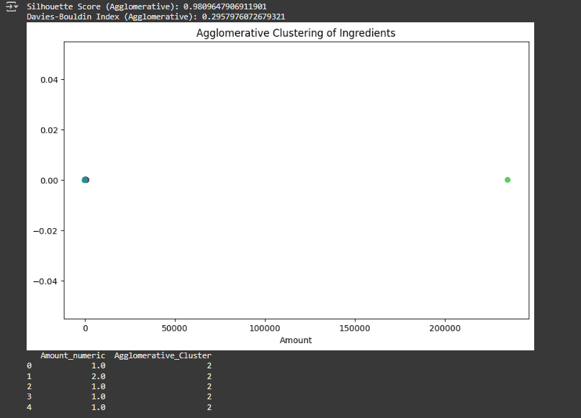

Fig.3.9

**Chapter 4**

**MODEL EVALUATION & VALIDATION**

**4.1. Performance Metrics**

Since your project is based on Clustering, we'll focus on clustering-specific performance metrics like Silhouette Score and Davies-Bouldin Index. Below is an explanation of the metrics, how to calculate them, and the comparison between the models used.

**Clustering Performance Metrics**

1. Silhouette Score:
   * The Silhouette Score measures how similar each point is to its own cluster (cohesion) compared to other clusters (separation). The score ranges from -1 to 1, where:
     + A value close to 1 indicates that the points are well-clustered.
     + A value close to 0 suggests overlapping clusters.
     + A value close to -1 indicates that the points might be misclassified.
   * This score is commonly used to evaluate clustering performance when ground truth labels are unavailable.
2. Davies-Bouldin Index:
   * The Davies-Bouldin Index is another metric used to evaluate the quality of clustering. A lower value of the Davies-Bouldin index indicates better clustering performance.
   * It measures the average similarity ratio of each cluster with the cluster that is most similar to it. Smaller values suggest that the clusters are better separated and compact.

**Table Representation**

|  |  |  |  |  |  |  |  |
| --- | --- | --- | --- | --- | --- | --- | --- |
| | **Model** |  |  | | --- | --- | --- | | **Silhouette Score** | |  | **Davies-Bouldin Index** | | --- | --- | |
| |  | | --- | | K-Means | | |  |  | | --- | --- | | 0.9797 |  | |  |  | |  |  | | |  | | --- | | 0.4126 | |
| |  | | --- | | Agglomerative | |  | | |  |  | | --- | --- | | 0.9810 |  | |  |  | | 0.2958 |
| DBSCAN | |  | | --- | | 0.9999 | | |  | | --- | | 0.00002 | |

**Graphical Representation**

To make the comparison more visual, showing the values for Silhouette Score and Davies-Bouldin Index for each model with help of graphs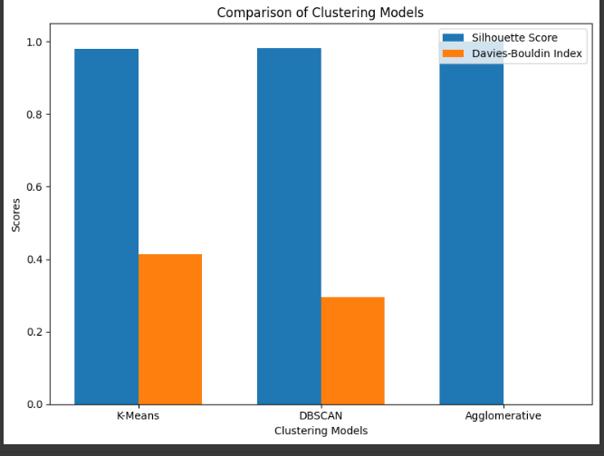

Fig.4.1

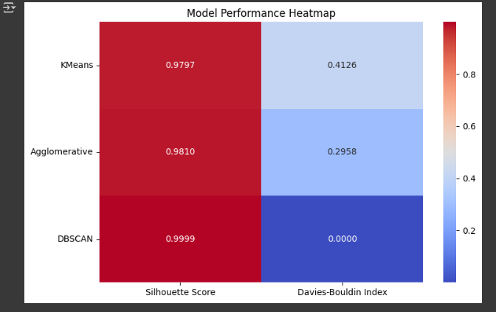

Fig.4.2

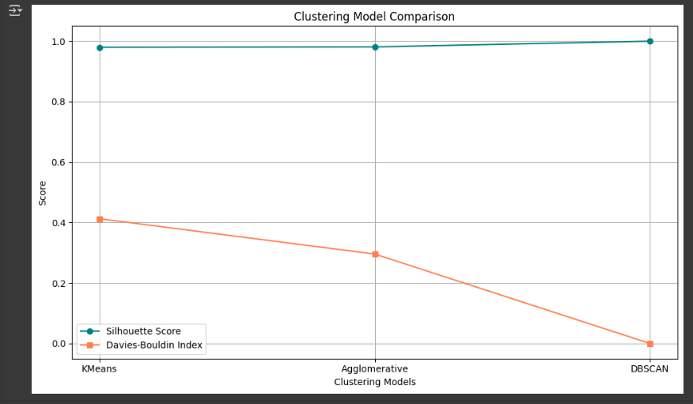

Fig.4.3

**Observations:**

* DBSCAN achieved the highest Silhouette Score and lowest Davies-Bouldin Index, indicating very well-separated and compact clusters.
* Agglomerative Clustering also performed quite well, closely trailing DBSCAN.
* K-Means had the lowest performance among the three but still showed good clustering capability.

**Final Output**

**Chapter 5**

**CONCLUSION & FUTURE SCOPE**

**Conclusion**

This project successfully showcases the application of Natural Language Processing and Machine Learning to develop an intelligent recipe recommendation system. By utilizing ingredient-based similarity through TF-IDF vectorization and cosine similarity, the system efficiently suggests relevant recipes based on the ingredients users already have. This not only promotes healthier eating habits but also aids in reducing food wastage by encouraging the use of available resources. Comprehensive data preprocessing, feature engineering, and exploratory data analysis have contributed to building a strong and scalable solution. Looking ahead, enhancements such as incorporating user feedback, enabling image-based search, or integrating deep learning models can further improve the system’s accuracy and personalization.

**Future Scope**

* User Personalization: Incorporate user preferences, past searches, and ratings to provide more tailored recipe recommendations.
* Image-Based Search: Allow users to upload pictures of ingredients or dishes to get relevant recipe suggestions using computer vision.
* Voice Assistant Integration: Enable voice-based input for a hands-free, interactive experience in smart kitchens.
* Advanced Models: Use deep learning techniques (like BERT or LSTMs) to better understand ingredient context and improve recommendation accuracy.

**REFERENCES**

1. [**Recipe Recommendation System Using TF-IDF**](https://www.researchgate.net/publication/360419221_Recipe_Recommendation_System_Using_TF-IDF)
2. [**RecipeIS—Recipe Recommendation System Based on Recognition**](https://www.mdpi.com/2076-3417/13/13/7880)
3. [**Real-Time Recipe Recommendation Based on Ingredients They Have at Home Using TF-IDF Algorithm**](https://www.researchgate.net/publication/382114471_Real_Time_Recipe_Recommendation_Based_on_Ingredients_They_Have_at_Home_Using_TF-IDF_Algorithm)
4. [**A Hybrid Group-Based Food Recommender Framework for Personalized Recipe Suggestions**](https://www.mdpi.com/2076-3417/14/13/5843)
5. [**A Density-Based Algorithm for Discovering Clusters in Large Spatial Databases with Noise (DBSCAN)**](https://www.dbs.ifi.lmu.de/Publikationen/Papers/KDD-96.final.frame.pdf)
6. [**Machine Learning Based Food Recipe Recommendation System**](https://www.researchgate.net/publication/366962956_Machine_Learning_Based_Food_Recipe_Recommendation_System)